How to demo ICU NPC

Created on 2013/12/15

Fortune Truong ([fortune.truong@gmail.com](mailto:fortune.truong@gmail.com))

How to spawn all NPCs (Patients + Doctors)

Automatically

Manually

How to modify the walking pattern of Doctors

Toggle weight point visibility

Modify weight point positions

How to chat with doctors

Troubleshoot

How to make the doctors wandering in the case they just stationary

# 

# 

# How to spawn all NPCs (Patients + Doctors)

## Automatically

A collider trigger has been set up on a phantom wall which located on the entrance of the ICU. Whenever the avatar go through it, it will emit ip_channel (-54321) and point_channel (-32768).

* ip_channel will tell the Region re-cache the database host address, and spawn all NPC (Patients + Doctors).
* point_channel will tell the Region re-cache all current position (x,y,z) of all weight points for doctors wandering script.

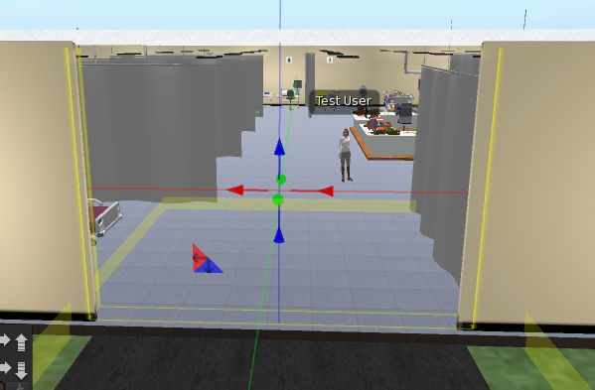

## Manually

Users also can touch on the grey cube next to the CPU under the table. It will do the same thing as the above trigger.

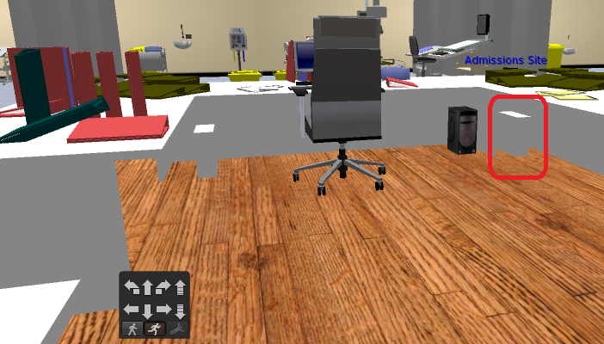

# 

# 

# How to modify the walking pattern of Doctors

## Toggle weight point visibility

Click on the gray cube to toggle on/off the weight point. It also contains the script which stores the possible connection between two points.

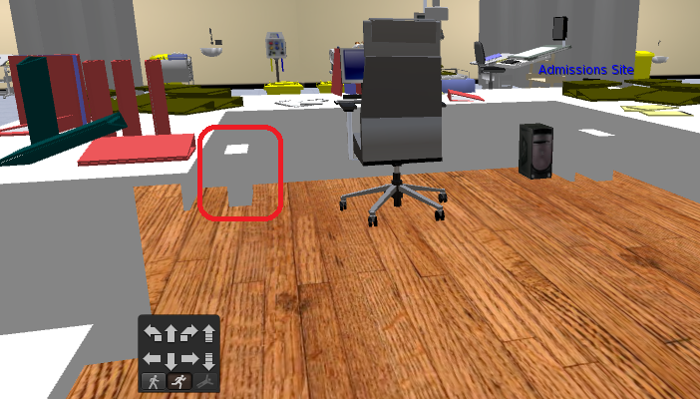

## Modify weight point positions

All weight points are able to be changed visually. After change their positions, user need to manually touch on the gray cube above to re-cache the new positions.

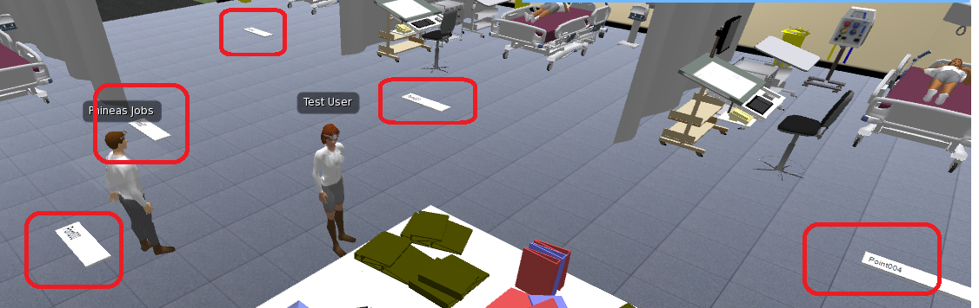

# 

# 

# How to chat with doctors

Also if user wanna chat with the doctor, use <Doctor Fullname> + <AIML question> or <AIML question> + <Doctor Fullname>.

I.E.

Hi Tommy Jobs

Tommy Jobs, is it cool to be a computer?

Bye Tommy Jobs

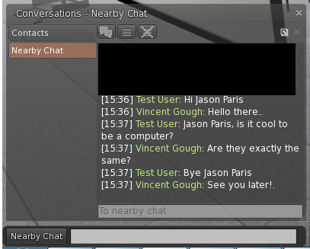

All AIML templates are saved under "AIML" folder in Opensim\bin\aiml



Note: NPCs must be spawned before they can handle chat.

# 

# 

# Troubleshoot

## How to make the doctors wandering in the case they just stationary

User need to manually modify and save "Spawn_Doctor" script in order to make it work.

*A couple ways have tried to reset it by llResetScript as well as llResetOtherScript but none of them are working, but they would be a way to make it work without this handy action.*